DATA ANALYSIS AND VISUALIZATION
PROJECT REPORT
(Project Semester August-December 2020)

Social Media Mental Stress
Intelligence Dashboard
Submitted by
Ratn Priya
Registration No. - 12408871

Section - 424ZC
Course Code – INT387

Under the Guidance of
Savleen Kaur (UID: 18306)

Discipline of CSE/IT
Lovely School of Computer Science and Engineering
Lovely Professional University, Phagwara


CERTIFICATE

This is to certify that Ratn Priya bearing Registration no. 12408871 has completed INT387 project titled, “Social Media Mental Stress Intelligence Dashboard” under my guidance and supervision. To the best of my knowledge, the present work is the result of his/her original development, effort and study.

Signature and Name of the Supervisor
Designation of the Supervisor
School of Computer Science and Engineering
Lovely Professional University
Phagwara, Punjab.

Date: 24/04/2026

DECLARATION

I, Ratn Priya, student of Computer Science and Engineering under CSE/IT Discipline at, Lovely Professional University, Punjab, hereby declare that all the information furnished in this project report is based on my own intensive work and is genuine.

Date: 24/04/2026 Signature
Registration No. 12408871 Name of the student
Ratn Priya

Table of Contents
- Cover page
- Declaration
- Acknowledgement
- Table of Content

- Introduction
- Objectives/Scope of the Analysis
- Source of dataset
- ETL process
- Analysis on dataset (for each analysis)
- Introduction
- General Description
- Specific Requirements, functions and formulas
- Analysis results
- Visualization
- List of Analysis with results
- References
- Bibliography

1. Introduction
Mental health disorders such as anxiety, post-traumatic stress disorder (PTSD), depression, and domestic trauma are increasingly being discussed and expressed through online social media platforms. Reddit, one of the world's largest discussion forums, hosts a wide range of mental health communities where users share personal experiences, seek advice, and express emotional distress in their own words.

This project presents a comprehensive Power BI dashboard titled Social Media Mental Stress Intelligence, built upon the Dreaddit dataset — a labelled collection of Reddit posts annotated for the presence or absence of psychological stress. The dashboard translates raw text and metadata into a multi-page interactive intelligence tool that surfaces patterns in stress behaviour, linguistic psychology, community risk, and sentiment across 10 mental health subreddits.

The project integrates three distinct analytical disciplines: Natural Language Processing (NLP) through sentiment and readability scores, psycholinguistics through LIWC (Linguistic Inquiry and Word Count) features, and Business Intelligence through Power BI visualisations. Together, they provide a 360-degree view of how stress manifests in online written communication.

The significance of this work lies in its real-world applicability. Mental health platforms, research institutions, and social media monitoring tools can leverage these insights to identify at-risk communities, flag high-stress content early, and design better support systems for vulnerable users.

2. Objectives and Scope of the Analysis

2.1 Primary Objectives
- Detect and quantify stress vs. non-stress behaviour across Reddit mental health communities using labelled NLP data.
- Analyse the psycholinguistic fingerprint of stressed writing using LIWC features such as pronoun usage, emotional tone, authenticity, and analytical thinking.
- Examine how social engagement metrics (karma, upvote ratio, comments) differ between stressed and non-stressed posts.
- Perform sentiment analysis to understand how emotional polarity correlates with stress classification.
- Identify and rank the highest-risk communities by stress detection rate and signal intensity.
- Build a fully interactive, professional-grade Power BI dashboard suitable for a data science portfolio.

2.2 Scope of the Analysis
The analysis is scoped to the Dreaddit training dataset only, containing 2,838 Reddit posts. The study is observational — it does not make clinical diagnoses but provides data-driven insights that could support mental health research. The scope covers:
- Five analytical dimensions: Overview, Behaviour, Psychology (LIWC), Sentiment, and Community Risk.
- Ten subreddits: r/ptsd, r/anxiety, r/relationships, r/domesticviolence, r/assistance, r/survivorsofabuse, r/homeless, r/almosthomeless, r/stress, r/food_pantry.
- Temporal coverage: posts from 2017 to 2018, captured via Unix timestamps.
- Feature coverage: 40+ columns including text, metadata, readability scores, sentiment, and LIWC psycholinguistic variables.

2.3 Out of Scope
- Real-time data collection or API integration with Reddit.
- Clinical interpretation or diagnosis of mental health conditions.
- Individual user tracking or personally identifiable information.

3. Source of Dataset

3.1 Dataset Overview
The dataset used in this project is the Dreaddit: A Reddit Dataset for Stress Analysis in Social Media, published by Elena Turcan and Kathy McKeown at Columbia University (2019). It is a publicly available benchmark dataset in the NLP and computational social science communities.
Attribute | Details
Full Name | Dreaddit: A Reddit Dataset for Stress Analysis
Authors | Elena Turcan, Kathy McKeown (Columbia University)
Year | 2019
Source | Reddit posts from 10 mental health subreddits
Total Records (Train) | 2,838 posts
Labels | Binary: 1 = Stress, 0 = Non-Stress
Annotation Method | Crowd-sourced via Amazon Mechanical Turk
Avg Confidence Score | 80.9% inter-annotator agreement
Features | 40+ columns: text, metadata, readability, sentiment, LIWC

3.2 Key Column Descriptions
Column Name | Type | Description
subreddit | Text | Name of the Reddit community the post came from
label | Binary (0/1) | Stress classification: 1 = Stress, 0 = Non-Stress
confidence | Float (0-1) | Annotator confidence score (avg agreement %)
sentiment | Float | VADER sentiment polarity score (-1 to +1)
social_karma | Integer | Author's total Reddit karma at time of post
social_upvote_ratio | Float | Ratio of upvotes to total votes
social_num_comments | Integer | Number of comments on the post
social_timestamp | Unix int | Post creation timestamp
syntax_ari | Float | Automated Readability Index score
syntax_fk_grade | Float | Flesch-Kincaid grade level
lex_liwc_i | Float | % of first-person singular pronouns (I, me, my)
lex_liwc_negemo | Float | % of negative emotion words
lex_liwc_anx | Float | % of anxiety-related words
lex_liwc_anger | Float | % of anger-related words
lex_liwc_sad | Float | % of sadness-related words
lex_liwc_posemo | Float | % of positive emotion words
lex_liwc_Analytic | Float | Analytical thinking score (0-100)
lex_liwc_Tone | Float | Emotional tone score (0-100, high = positive)
lex_liwc_Authentic | Float | Authenticity score (personal, genuine language)
lex_liwc_Clout | Float | Social confidence and status in language

4. ETL Process
The ETL (Extract, Transform, Load) process was performed entirely within Power BI Desktop using Power Query Editor for data transformation and DAX (Data Analysis Expressions) for measure creation. No external tools or scripts were required.

4.1 Extract — Loading the Raw Data
- Opened Power BI Desktop and navigated to Home tab → Get Data → Text/CSV.
- Selected the dreaddit-train.csv file from the local file system.
- Power BI displayed a preview of all 2,838 rows and 40+ columns.
- Clicked Load to import the dataset into the Power BI data model.

4.2 Transform — Power Query Cleaning Steps

4.2.1 Label Column Conversion
The label column arrived as integer values (0 and 1). This was converted to human-readable text for chart readability:
- Changed data type of label column to Text.
- Used Replace Values: 1 → "Stress", 0 → "Non-Stress".
- This allowed chart legends and slicers to display meaningful labels instead of binary codes.

4.2.2 Timestamp to Date Conversion
The social_timestamp column contained Unix epoch timestamps (seconds since 1 Jan 1970). This was converted to a usable date field using the following Power Query custom column formula:
#datetime(1970,1,1,0,0,0) + #duration(0,0,0,[social_timestamp])
The resulting column was renamed PostDate and its data type was set to Date.

4.2.3 Calculated Columns
Column Name | Formula / Method | Purpose
PostLength | Text.Length([text]) | Character count of each post
SentimentBin | Custom M formula with if-else | Categorises sentiment into 5 buckets
StressCategory | if [confidence] >= 0.9 then ... | Confidence-tier classification

4.2.4 SentimentBin Formula
if [sentiment] < -0.5 then "1-Very Negative" else if [sentiment] < -0.05 then "2-Negative" else if [sentiment] < 0.05 then "3-Neutral" else if [sentiment] < 0.5 then "4-Positive" else "5-Very Positive"

4.3 Load — DAX Measures Created
After closing Power Query, the following DAX measures were created in the data model to power KPI cards and aggregations:
Measure Name | DAX Formula | Used On
Total Posts | COUNTROWS('dreaddit-train') | All pages
Stress Count | COUNTROWS(FILTER(table, label="Stress")) | Overview
Stress % | DIVIDE([Stress Count],[Total Posts])*100 | Overview
Avg Sentiment | AVERAGE([sentiment]) | Sentiment page
Avg Confidence | AVERAGE([confidence])*100 | Overview
Avg Karma | AVERAGE([social_karma]) | Behavior page
Stress Rate % | DIVIDE(Stress Count, Total Posts)*100 | Community Risk
Sentiment Gap | AVG(Stress sentiment) - AVG(Non-Stress sentiment) | Sentiment page

5. Analysis on Dataset
The dashboard is structured into five analytical pages, each addressing a distinct dimension of stress intelligence. Each analysis section below follows the required structure: introduction, general description, specific requirements and formulas, results, and visualisation.

5.1 Overview Analysis

i. Introduction
The Overview page provides a high-level summary of the entire dataset. It answers the foundational question: how prevalent is stress across Reddit mental health communities, and how has it changed over time?

ii. General Description
This page aggregates the full 2,838-post dataset into four KPI metrics, a proportional split chart, a community-level breakdown, and a temporal trend. It serves as the entry point for any user or stakeholder who wants an at-a-glance understanding of the data.

iii. Specific Requirements, Functions and Formulas

Visual | Fields Used | Key Formula / Setting
KPI Card — Total Posts | Total Posts measure | COUNTROWS('dreaddit-train')
KPI Card — Stress % | Stress % measure | DIVIDE(Stress Count, Total Posts)*100
KPI Card — Avg Confidence | Avg Confidence measure | AVERAGE([confidence])*100
KPI Card — Avg Sentiment | Avg Sentiment measure | AVERAGE([sentiment])
Donut Chart | label (Legend), Total Posts (Values) | Color: Stress=#f87171, Non-Stress=#22d3a0
100% Stacked Bar | subreddit (Y), Total Posts (X), label (Legend) | Sorted descending by Stress Count
Line Chart | PostDate (X), Stress Count + Non-Stress Count (Y) | Shade area under stress line enabled

iv. Analysis Results
- 52.4% of all posts (1,488 out of 2,838) were classified as stress — indicating stress is the majority state in these communities.
- Average model confidence was 80.9%, confirming reliable annotation quality.
- r/anxiety showed the highest absolute stress volume (331 stress posts), while r/domesticviolence had the highest stress ratio (63.9%).
- The stress trend shows clear seasonal peaks in summer months (Jun-Aug) and late autumn (Nov), potentially linked to academic and seasonal affective patterns.

v. Visualisation
Page 1 uses a dark-themed canvas with four accent-bordered KPI cards at the top, a 100% stacked horizontal bar chart for subreddit comparison, a donut chart for the stress split, and a dual-line area chart for the monthly trend. Two tile/dropdown slicers enable full cross-filtering across all visuals.

5.2 Behavioral Signal Analysis

i. Introduction
The Behavior page investigates whether stressed Reddit users behave differently in terms of social engagement metrics. Specifically, it examines karma, comment count, and upvote ratio as proxies for community response to stressed versus non-stressed posts.

ii. General Description
Social engagement on Reddit is driven by votes, comments, and the overall karma of the author. If stressed posts receive systematically different engagement, this provides a behavioral fingerprint of stress that exists independent of the text content itself — making it a valuable cross-validation signal.

iii. Specific Requirements, Functions and Formulas
Visual | Fields Used
Bar Chart — Karma | label (X), social_karma (Y-Average)
Bar Chart — Comments | label (X), social_num_comments (Y-Average)
Bar Chart — Upvote Ratio | label (X), social_upvote_ratio (Y-Average)
Summary Table | label, Avg Karma, Avg Confidence, Avg Sentiment

iv. Analysis Results
Metric | Stress Posts | Non-Stress Posts | Difference
Avg Social Karma | 14.22 | 22.72 | Non-Stress 60% higher
Avg Num Comments | 9.15 | 10.83 | Non-Stress 18% higher
Avg Upvote Ratio | 0.860 | 0.826 | Stress slightly higher
Avg Sentiment Score | -0.016 | 0.103 | Non-Stress 7.4x more positive
Avg Model Confidence | 81.3% | 80.5% | Comparable

v. Visualisation
Two clustered bar charts are arranged side by side, each comparing one metric across Stress and Non-Stress. A summary table below uses conditional gradient color formatting — for lower/worse values, for higher/better values — creating an instant heatmap-style comparison.

5.3 Sentiment Analysis

i. Introduction
The Sentiment page analyses the VADER (Valence Aware Dictionary and sEntiment Reasoner) sentiment scores pre-computed for each post. Sentiment analysis quantifies the emotional polarity of text on a scale from -1 (very negative) to +1 (very positive).

ii. General Description
Sentiment score serves as a lightweight proxy for emotional state. While it does not capture the complexity of clinical stress, it provides a fast signal that is highly correlated with stress classification in this dataset — making it a practically useful feature for early detection systems.

iii. Specific Requirements and Functions
Visual | Fields Used
KPI Cards (4) | Negative Posts, Neutral Posts, Positive Posts, Sentiment Gap measures
Histogram (Column Chart) | SentimentBin (X), Total Posts (Y)
Bar Chart — Sentiment by Label | label (X), sentiment (Y-Average)
Bar Chart — By Subreddit | subreddit (Y), sentiment (X-Average)

iv. Analysis Results
- 47.8% of all posts scored positively on sentiment — even within stressed communities, many users frame experiences constructively or express gratitude.
- Stress posts averaged -0.016 sentiment vs +0.103 for non-stress — a gap of 0.119 points.
- r/domesticviolence and r/ptsd showed the most consistently negative average sentiment by subreddit.
- r/assistance and r/food_pantry showed the most positive sentiment, reflecting solution-oriented posting behaviour.
- Very Negative posts (score < -0.5) accounted for only 1% of all posts — most negativity falls in the mild range.

v. Visualisation
The Sentiment page presents a colour-coded histogram of sentiment distribution across five bins, a side-by-side average bar chart for stress vs non-stress, and a horizontal subreddit bar chart with diverging conditional formatting — bars for negative communities and for positive ones, auto-calculated by Power BI.

5.4 Community Risk Analysis

i. Introduction
The Community Risk page identifies which subreddits represent the highest concentration of stress-related posts. This is the actionable dimension of the dashboard — if a mental health organisation wanted to prioritise intervention, this page tells them exactly where to focus resources.

ii. General Description
Risk is defined here as the proportion of posts classified as stress within each subreddit. A community with 60%+ stress rate is classified as HIGH risk, 50-60% as MEDIUM, and below 50% as LOW. Both absolute volume and stress ratio are visualised to distinguish communities that are large vs. those that are proportionally most distressed.

iii. Specific Requirements, Functions and Formulas
Visual | Fields Used
KPI Cards (4) | Stress Rate % filtered per subreddit, Total Posts
Risk Ranking Bar | subreddit (Y), Stress Rate % (X)
Bubble/Scatter Chart | Total Posts (X), Stress Rate % (Y), Total Posts (Size), subreddit (Legend)
Heatmap Matrix | subreddit (Rows), label (Columns), Total Posts + Stress % (Values)

iv. Analysis Results
Subreddit | Total Posts | Stress Posts | Stress Rate % | Risk Level
r/anxiety | 503 | 331 | 65.8% | HIGH
r/domesticviolence | 316 | 202 | 63.9% | HIGH
r/almosthomeless | 80 | 47 | 58.8% | MEDIUM
r/ptsd | 584 | 332 | 56.8% | MEDIUM
r/stress | 64 | 35 | 54.7% | MEDIUM
r/relationships | 552 | 247 | 44.7% | LOW
r/survivorsofabuse | 245 | 112 | 45.7% | LOW
r/homeless | 168 | 63 | 37.5% | LOW
r/food_pantry | 37 | 14 | 37.8% | LOW
r/assistance | 289 | 105 | 36.3% | LOW

v. Visualisation
The Community Risk page uses four filtered KPI cards for quick reference, a conditionally coloured lollipop bar chart with a 50% reference line as the risk threshold, a bubble chart to simultaneously show volume and risk rate, and a gradient heatmap matrix where cell colour intensity directly encodes stress rate per community and label group.

6. List of Analysis with Results
The following table consolidates all key findings from the five analytical pages into a single reference summary:

# | Analysis | Key Metric | Result | Insight
1 | Stress Prevalence | Stress % | 52.4% | Majority of posts show stress signals
2 | Model Confidence | Avg Confidence | 80.9% | High annotation reliability
3 | Karma — Stress | Avg Karma | 14.22 vs 22.72 | Stressed users get 37% less karma
4 | Comments — Stress | Avg Comments | 9.15 vs 10.83 | Fewer replies to stressed posts
5 | Upvote Ratio | Avg Ratio | 0.860 vs 0.826 | Community upvotes stressed posts more
6 | I-pronoun Usage | LIWC lex_liwc_i | 10.84% vs 7.11% | Self-focus increases 52% under stress
7 | Negative Emotion | LIWC negemo | 4.42% vs 2.07% | Negative words double under stress
8 | Analytic Thinking | LIWC Analytic | 28.99 vs 42.13 | Logic drops significantly when stressed
9 | Tone Score | LIWC Tone | 18.76 vs 49.60 | Emotional tone far more negative
10 | Authenticity | LIWC Authentic | 75.66 vs 57.54 | Stressed writing more genuine/raw
11 | Sentiment Gap | Avg Sentiment | -0.016 vs +0.103 | Clear negative polarity in stress posts
12 | Highest Risk | Stress Rate % | r/anxiety: 65.8% | Top community by stress proportion
13 | Largest Volume | Total Posts | r/ptsd: 584 posts | Largest community in dataset
14 | Lowest Risk | Stress Rate % | r/assistance: 36.3% | Most solution-oriented community
15 | Positive Sentiment | % Positive Posts | 47.8% | Nearly half of all posts are positive

7. References
- Turcan, E., & McKeown, K. (2019). Dreaddit: A Reddit Dataset for Stress Analysis in Social Media. Proceedings of the Tenth Workshop on Computational Approaches to Subjectivity, Sentiment and Social Media Analysis (WASSA 2019). Association for Computational Linguistics.

- Pennebaker, J. W., Boyd, R. L., Jordan, K., & Blackburn, K. (2015). The Development and Psychometric Properties of LIWC2015. University of Texas at Austin.

- Hutto, C. J., & Gilbert, E. (2014). VADER: A Parsimonious Rule-Based Model for Sentiment Analysis of Social Media Text. Proceedings of the Eighth International AAAI Conference on Weblogs and Social Media.

- Microsoft Corporation. (2024). Power BI Desktop — Documentation and DAX Reference. Retrieved from https://docs.microsoft.com/en-us/power-bi/

- Kincaid, J. P., Fishburne, R. P., Rogers, R. L., & Chissom, B. S. (1975). Derivation of new readability formulas for Navy enlisted personnel. Research Branch Report 8-75. Chief of Naval Technical Training.

- Reddit Inc. (2023). Reddit Data API Documentation. Retrieved from https://www.reddit.com/dev/api

8. Bibliography
The following works informed the conceptual framework, analytical methods, and visualisation design of this project, though they may not be directly cited in the report body:

- Coppersmith, G., Dredze, M., & Harman, C. (2014). Quantifying Mental Health Signals in Twitter. Proceedings of the Workshop on Computational Linguistics and Clinical Psychology.

- De Choudhury, M., Gamon, M., Counts, S., & Horvitz, E. (2013). Predicting Depression via Social Media. Proceedings of the International AAAI Conference on Web and Social Media.

- Gonzalez-Hernandez, G., Sarker, A., O'Connor, K., & Savova, G. (2017). Capturing the Patient's Perspective: a Review of Advances in Natural Language Processing of Health-Related Text. Yearbook of Medical Informatics.

- Tausczik, Y. R., & Pennebaker, J. W. (2010). The Psychological Meaning of Words: LIWC and Computerized Text Analysis Methods. Journal of Language and Social Psychology, 29(1), 24-54.

- Few, S. (2012). Show Me the Numbers: Designing Tables and Graphs to Enlighten (2nd ed.). Analytics Press.

- Cairo, A. (2016). The Truthful Art: Data, Charts, and Maps for Communication. New Riders.

- Ware, C. (2020). Information Visualization: Perception for Design (4th ed.). Morgan Kaufmann.

- Screenshot of dashboard:

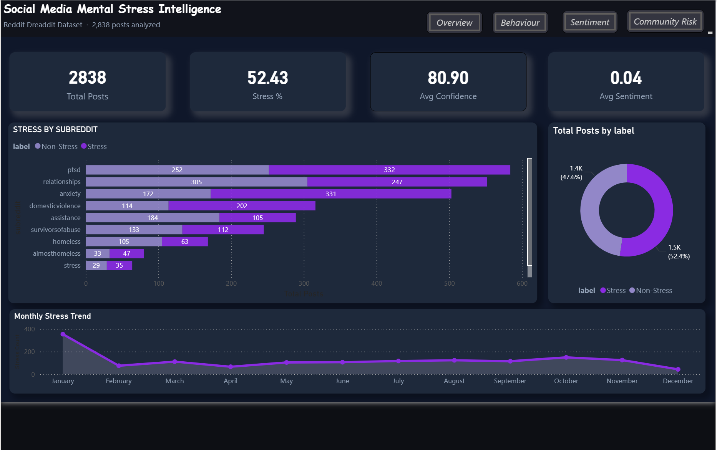

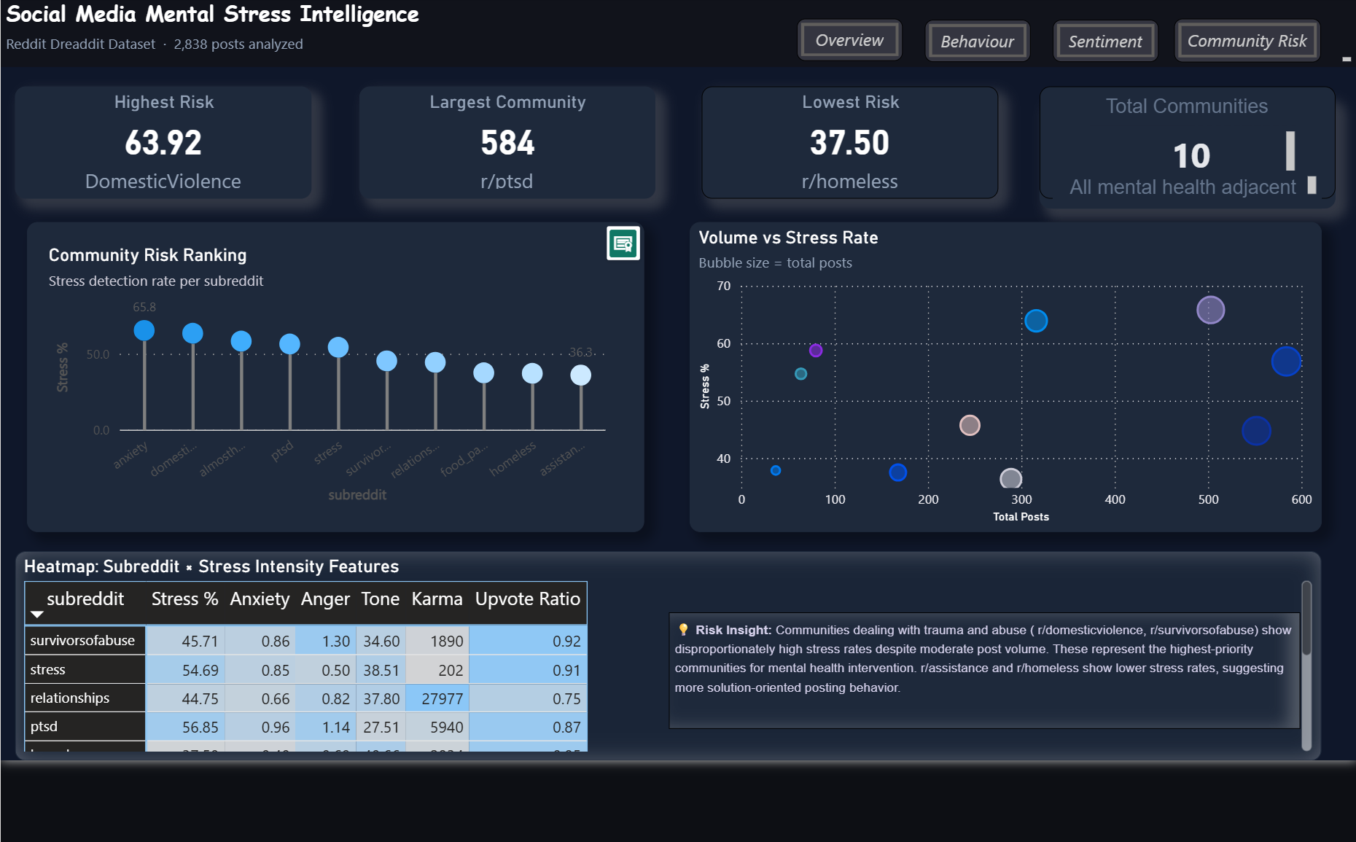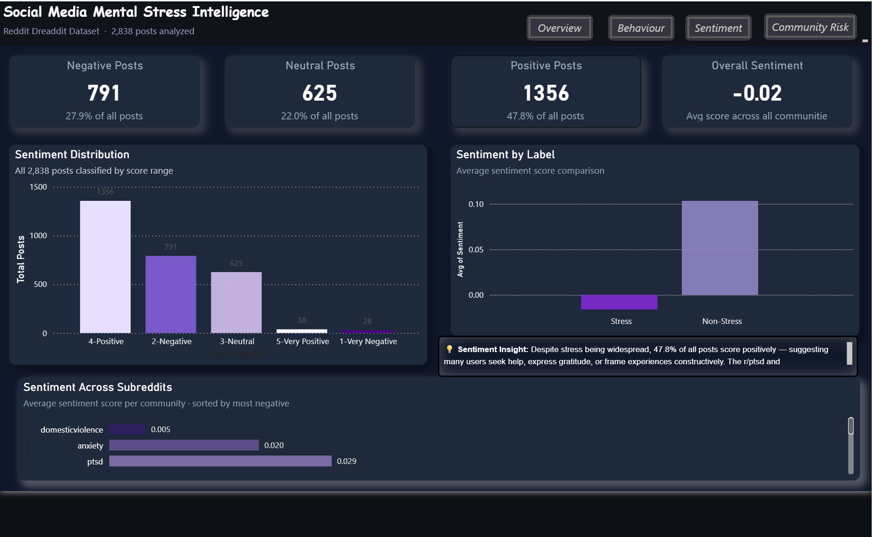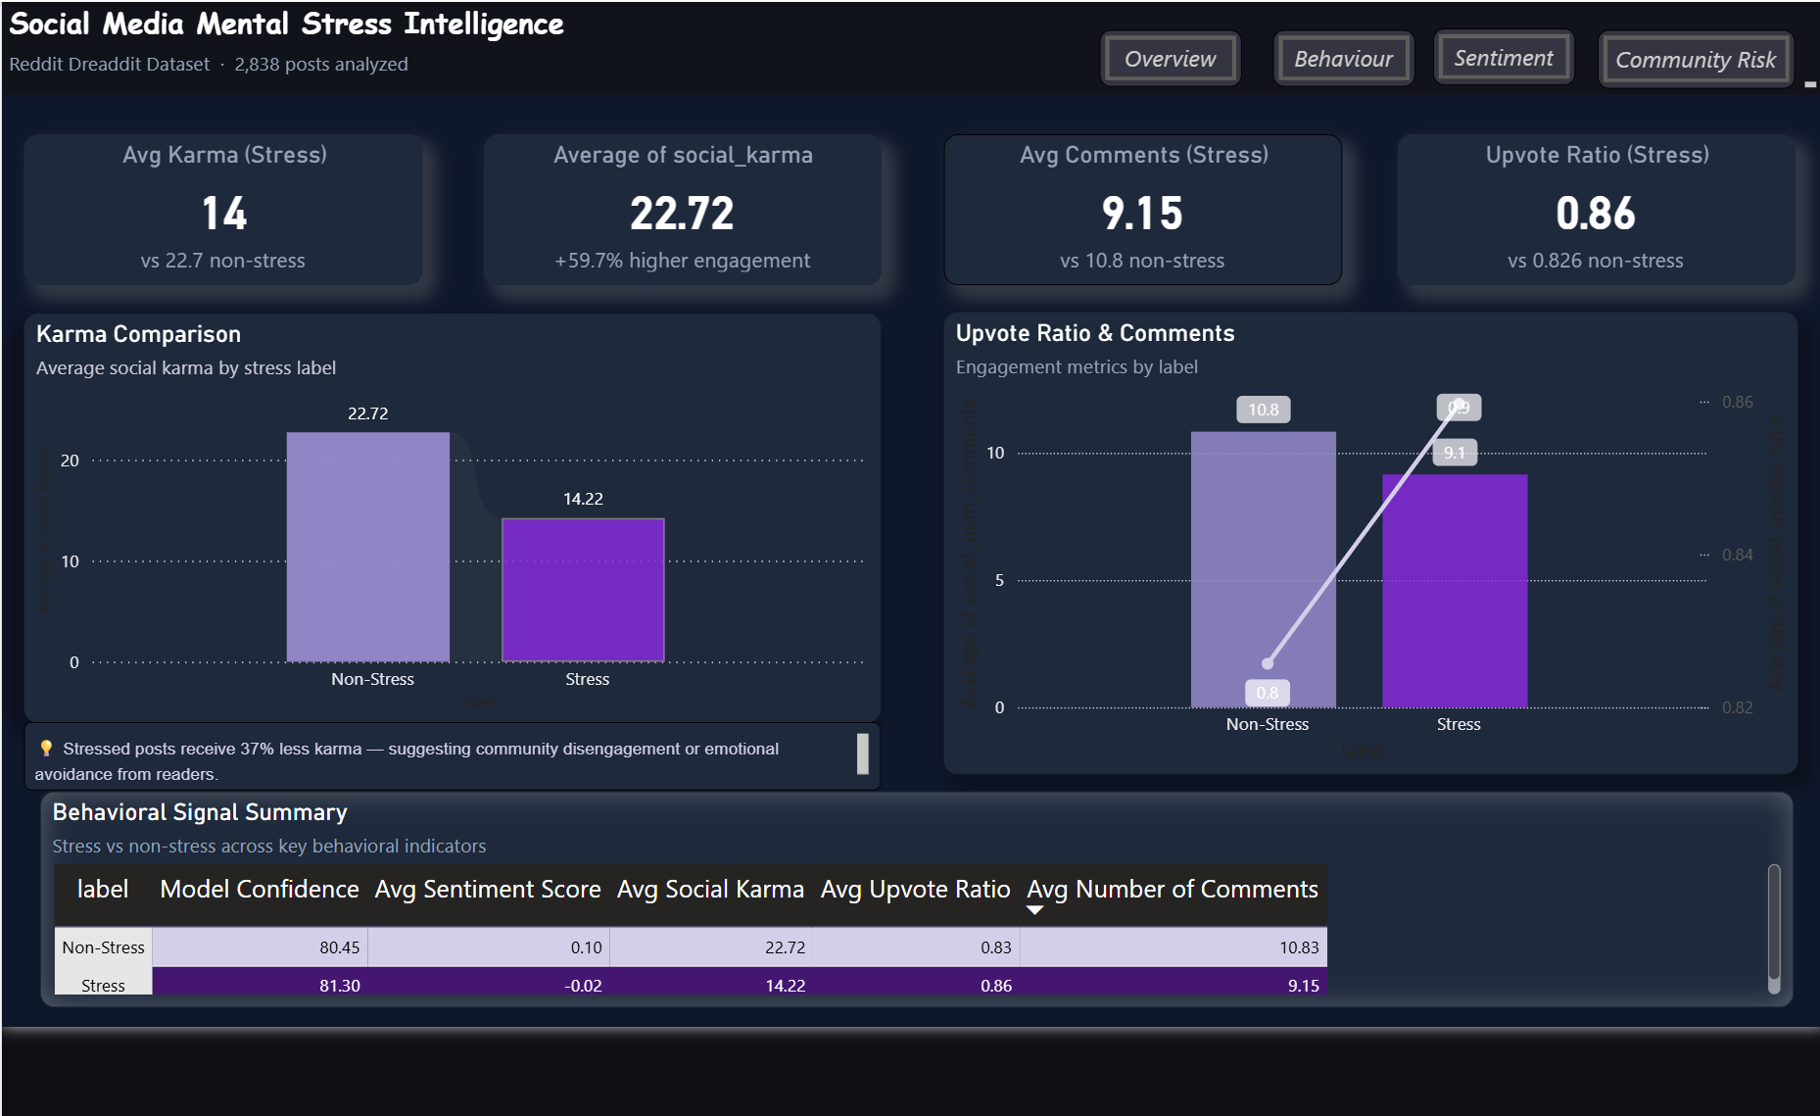
Dataset screenshot:

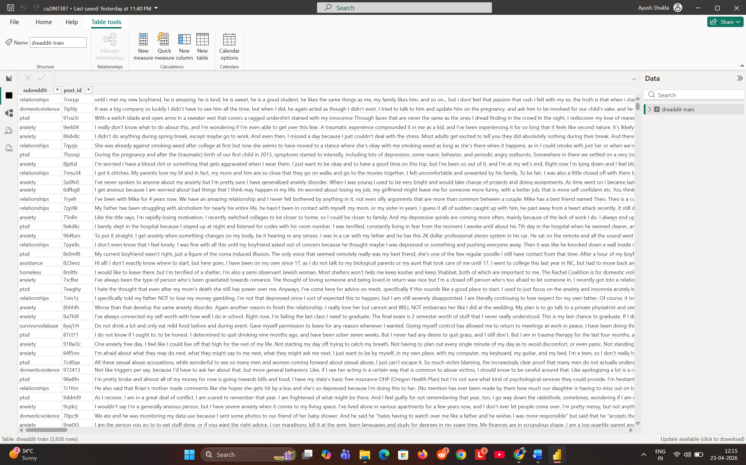

Linkedin post:
https://www.linkedin.com/feed/update/urn:li:activity:7452957837137219584/

Google drive link:
https://drive.google.com/drive/folders/16Y24EXD4w6QpGPR6OBFLaqWNdqDRgecQ?usp=sharing

— End of Report —

